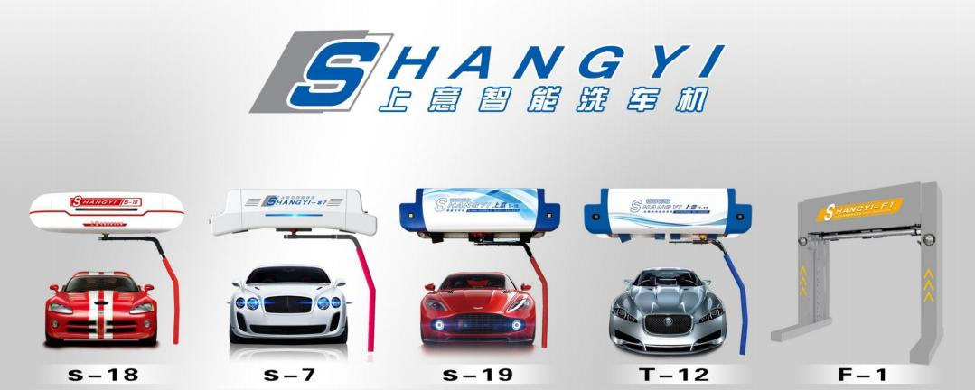

型号  Model Number | S-18 | S-7 | S-19 | T-12 | F-1
价格  Price(USD) | 11800(s) | 13900(s) | 15080(s) | 17800(s) | 22800(s)
价格  Price(CNY) | 85550(¥) | 100775(¥) | 109330(¥) | 129050(¥) | 165300¥)
安装运输  Installation and transportation | 不含运费安装费用（免费安装：免费远程指导安装 。现场安装：上门安装服务人工费 500 元/天/人，机票及吃住客户安排）  Excluding transportation and installation costs (free installation: free remote guidance installation. on-site installation:  on-site installation service labor cost of 500 yuan/day/person, air tickets and accommodation arranged by customers)
安装尺寸 Installation dimensions | 长 6.8*宽 3.6*高 3M L6.8M * W3.6M * H 3M | 长 6.8M*宽 3.6M*高 2.9M L6.8M * W3.6M * H 2.9M | 长 7M*宽 3.6M*高 3.2M L7M * W3.6M * H3.2M | 长 7M*宽 3.6M*高 3.2M L7M * W3.6M * H3.2M | 长 8M*宽 3.6M*高 3.2M L8M * W3.6M * H3.2M

机架结构  Rack structure | L 臂中心旋转  L-arm center rotation |  | L 臂中心旋转  L-arm center rotation |  | L 臂中心旋转  L-arm center rotation | L 臂 平移  L-arm translation | 横臂自动升降  Automatic lifting of  flushing arm
洗车尺寸 Car wash dimensions | 长 5.6M*宽 2M*高 2M(超过这个尺寸的洗车机需要定制) L5.6M * W2M * H 2M (More than this size Car washing machine needs to be customized)
保修/交付期  Warranty/Deliv  ery Period | 我们的报价为离岸价，签定合同交付 30%定金，余款在发货之前结清，正常交货日期为 10 个工作日内；整机质保三年。  Our quotation is FOB, with a 30% deposit upon signing the contract, and the balance settled before shipment. The normal delivery  date is within 10 working days; The warranty for the complete machine is three years.
功 能 配 置 Functional configuration | 底盘轮毂冲洗  Chassis hub flushing
功 能 配 置 Functional configuration | 侧门冲洗  Side door flushing
功 能 配 置 Functional configuration | 360 ° 中心轴式高压冲洗  360 °center shaft type high  pressure flushing | 360 ° 中心轴式高压冲洗  360 °center shaft type high  pressure flushing |  | 360 ° 中心轴式高压冲洗  360 °center shaft type high  pressure flushing |  | 360 °横移式环绕高压冲洗  360 °traverse type  surround high pressure  flushing | 180 °上下升降高压清洗  180 ° up and down high  pressure cleaning
功 能 配 置 Functional configuration | 360 ° 中心轴环绕喷洒洗车液  360 °center axis type  surround car wash potion | 360 ° 中心轴环绕喷洒洗车液  360 °center axis type  surround car wash potion |  | 360 ° 中心轴环绕喷洒洗车液  360 °center axis type  surround car wash potion |  | 360 °横移式环绕喷洒洗车液  360 °traverse type  surround car wash potion | 180 °上下喷洒洗车液  Spray car wash up and  down at 180 °
功 能 配 置 Functional configuration | 触屏控制系统  Touch screen control system
功 能 配 置 Functional configuration | “双电脑 ”双 PLC  "Dual computer" dual PLC
功 能 配 置 Functional configuration | 自动识别车辆长度  Automatically identify vehicle length
功 能 配 置 Functional configuration | 自动停车检测到位  Automatic parking detection in place
功 能 配 置 Functional configuration | “陶瓷芯 ”万向旋转接头  "Ceramic core" universal rotary joint
功 能 配 置 Functional configuration | 灯光安全报警  Light safety alarm

功 能 配 置 Functional configura | 机械 + 电子防碰撞  Mechanical+electronic anti-collision
功 能 配 置 Functional configura | 遥控一键启动  Remote control one button  start | 遥控一键启动+多功能  Remote control one  button  start+multifunction | 遥控一键启动+多功能  Remote control one  button  start+multifunction |  | 遥控一键启动+多功能  Remote control one  button  start+multifunction | 遥控一键启动+多功能  Remote control one  button  start+multifunction
功 能 配 置 Functional configura | 故障自检系统  Fault self inspection system
功 能 配 置 Functional configura | 机械排液  Mechanical drainage | 一键排液/机械排液  One button  drainage/mechanical  drainage | 一键排液/机械排液  One button  drainage/mechanical  drainage |  | 一键排液/机械排液  One button  drainage/mechanical  drainage | 一键排液/机械排液  One button  drainage/mechanical  drainage
功 能 配 置 Functional configura | 热镀锌+喷塑机身  Hot galvanizing+spray molding machine body | 热镀锌+喷塑机身  Hot galvanizing+spray molding machine body | 不锈钢机身  Stainless steel equipment body |  | 不锈钢机身  Stainless steel equipment body | 不锈钢机身  Stainless steel equipment body
功 能 配 置 Functional configura | 洗车计数系统  Car wash counting system
功 能 配 置 Functional configura | 多种洗车程序计数系统  Counting system for various car washing procedures
功 能 配 置 Functional configura | 漏电保护系统  Leakage protection system
功 能 配 置 Functional configura | 智能保养提示  Intelligent maintenance tips
tion | 上压式齿轮行走  Down pressure gear travel | 内嵌滑轨式行走  Embedded slide rail  travel | 上压式齿轮行走  Down pressure gear  travel | 上压式齿轮行走  Down pressure gear  travel |  | 地轨式行走  Ground rail walking
tion | 水、液管路分离  Separation of water and  liquid pipelines | 3+N 管路分离  3+N pipeline separation | 3+N 管路分离  3+N pipeline separation | 3+N 管路分离  3+N pipeline separation |  | 3+N 管路分离  3+N pipeline separation
tion |  | 注塑内嵌式移动风干（4*4KW）  Injection molding  built-in mobile air  drying (4*4KW) | 注塑内嵌式移动风干（4*5.5KW）  Injection molding  built-in mobile air  drying (4*5.5KW) | 注塑内嵌式移动风干（4*5.5KW）  Injection molding  built-in mobile air  drying (4*5.5KW) |  | 注塑内嵌式移动风干（4*5.5KW）  Injection molding  built-in mobile air  drying (4*5.5KW)

n  功 能 配 置 Functional co |  | 消音减震系统  Sound attenuation and damping system
n  功 能 配 置 Functional co |  | LED 流程提示  LED process prompts | LED 流程提示  LED process prompts | LED 流程提示  LED process prompts | 双 LED 流程提示  Dual LED process prompt
n  功 能 配 置 Functional co | 水蜡镀膜上光（选配）  Water displacement  polishing wax (optional) | 水蜡镀膜上光  Water displacement polishing wax
n  功 能 配 置 Functional co | 液体自动配比（选配）  Automatic liquid  proportioning (optional) | 液体自动配比  Automatic liquid proportioning
n  功 能 配 置 Functional co |  | 五彩高泡（选配）  Colorful high foam  (optional) | 五彩高泡  Colorful high foam | 五彩高泡（选配）  Colorful high foam  (optional) | 五彩高泡  Colorful high foam
figuration |  | 瀑布式水幕洗车液(可选)  Waterfall Water Curtain  Car Wash (optional) | 瀑布式水幕洗车液(可选)  Waterfall Water Curtain  Car Wash (optional) | 瀑布式水幕洗车液  Waterfall Water Curtain  Car Wash | 瀑布式水幕洗车液(可选)  Waterfall Water Curtain  Car Wash (optional)
figuration | 基础语言功能：中文+英文（其他语言可定制）Basic language function: Chinese+English (other languages can be customized)
主机泵  Main engine  pump | 德国麦斯腾  PERFECT M POWER
水泵功率  Pump power | 380V 15KW | 380V 15KW | 380V 15KW | 380V 15KW | 380V 18.5KW
耗水量  water  consumption | 80L-120L | 80L-120L | 90L-140L | 90L-120L | 100L-200L
耗电量  power  consumption | 0.5 度/车  0.5 degree/vehicle | 0.5-1.5 度/车  0.5-1.5 degree/vehicle | 0.5-1.5 度/车  0.5-1.5 degree/vehicle | 0.5-1.5 度/车  0.5-1.5 degree/vehicle | 0.5-1.5 度/车  1-1.5 degree/vehicle
最大压力  Maximum  pressure | 100 公斤  100KG | 120 公斤  120KG | 140 公斤  140KG | 140 公斤  140KG | 140 公斤  140KG

洗车时间  Car wash time | 2 分钟  2 minutes | 3-6 分钟  3-6 minutes | 3-6 分钟  3-6 minutes | 3-6 分钟  3-6 minutes | 3-6 分钟  3-6 minutes
设备重量和立方米
Equipment weight and cubic meter
型号  Model Number | S-18 | S-7 | S-19 | T-12 | F-1
重量(kg)  weight(kg) | 1800 | 2000 | 2500 | 2500 | 1700
立方  cube | 7 | 8 | 8 | 8 | 16.9
客户安装准备
Installation Preparations
洗车房尺寸  Car wash room  dimensions | 有一个符合洗车机安装尺寸的房间，还需要一个占地面积超过 5 平方米的主机房，对长度、宽度和高度没有要求（用于储存主机的电源、  水和气源）  There is a room that meets the size of the installation of a car wash machine, and a main machine room with a floor area  of more than 5 square meters is also required, with no length, width, and height requirements (for storing power, water,  and gas sources of the main machine)
附属设施  Ancillary  facilities | 380V 三相四线制电源，2 立方米以上的水箱、水桶或水池，30 升及以上的气泵，2 套脚手架，叉车。有关详细计划，请参阅安装说明手册  380V three-phase four-wire power supply, water tanks, buckets, or pools with a capacity of more than 2 cubic meters, air  pumps with a capacity of 30 liters or more, 2 sets of scaffolding, and forklift trucks. For detailed plans, see the installation  instruction manual
地基建设 Foundation construction | 洗车房内排水沟建议（宽 0.6 米长 6.5 米），2 道地喷槽（宽：10 公分 深：10 公分 长：3.2 米）具体方案参考安装手册  Suggested drainage ditch in the car wash room (width: 0.6m, length: 6.5m), 2 ground spray tanks (width: 10cm, depth: 10cm,  length: 3.2m) Refer to the installation manual for the specific scheme

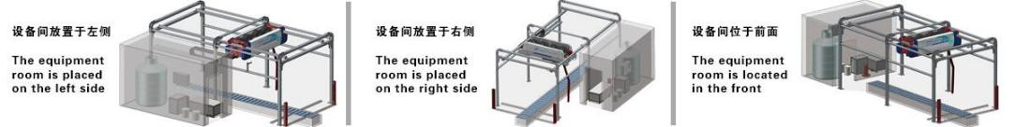

公司简介
Company Profile
公司成立于 1985 年，前身为“新华机械厂 ”主要生产汽车配件:刹车盘、刹车泵、分离轴承、独立悬挂等系列产品。1992 年独立研发生产工业加湿器和
保温材料设备(矿棉生产线)，应市场需求 2005 年开始研发无接触高压洗车机，2008 年成立石家庄新洁龙科技有限公司，凭借 20 年的科技研发实力，结合
国际先进科技，首先成功的研制出具有国际水平的“ 中国上意无接触洗车机 ”，并于 2010 年获得“全方位电脑自动洗车机 ”“全方位免擦拭洗车机横向行
走箱 ”“全方位环绕型洗车臂 ”三项中国实用新型专利证书。从此打开了国内无接触洗车机的新篇章，经十多年的时间产品不断改造升级，智能洗车机、无
人值守、远程控制、远程报警、营销引流功能的开发，产品畅销全国以及出口美国、俄罗斯、瑞典、摩洛哥、 日本、韩国、泰国等多个国家。
The company was founded in 1985, formerly known as "Xinhua Machinery Factory", mainly produces automotive accessories:
brake discs, brake pumps, release bearings, independent suspensions, and other series of products. In 1992, I independently
developed and produced industrial humidifiers and thermal insulation material equipment (mineral wool production line). In response
to market demand, I began to develop contactless high-pressure car washing machines in 2005. In 2008, I established Shijiazhuang
Xinjielung Technology Co., Ltd., relying on 20 years of scientific and technological research and development strength, combined
with international advanced technology, and first successfully developed the internationally renowned "China Shangyi Contactless
Car Washing Machine", In 2010, the company obtained three Chinese utility model patent certificates, namely, "omni-directional
computer automatic car wash machine", "omni-directional wiping free car wash machine lateral traveling box", and "omni-directional
surround type car wash arm". Since then, a new chapter has been opened for contactless car washing machines in China. After
more than a decade of continuous product transformation and upgrading, the development of intelligent car washing machines,
unattended, remote control, remote alarm, and marketing diversion functions has led to best-selling products nationwide and
exported to the United States, Russia, Sweden, Morocco, Japan, South Korea, Thailand, and other countries.

